## **Chapter 4: Hardware Selection**

### **Introduction**

In any robotics project, the hardware serves as the foundation that turns innovative ideas into functional reality. For Cleaning Boat, an autonomous boat designed to collect waste in marine and lake environments, the hardware is the physical core that determines how effectively it can navigate waterways, detect debris, and execute its environmental cleanup mission. Selecting the right hardware isn’t about choosing the most advanced or expensive components, it’s about finding the optimal combination that aligns with Cleaning Boat’s goals, balancing performance, compatibility, cost, and resilience against water and debris.

### **Processing unit**

For *Boat Cleaning*, the processing unit must handle multiple critical tasks: running the Robot Operating System (ROS Noetic) for seamless component integration, executing an AI model for real-time waste detection from camera images, processing sensor data for navigation, and controlling motors for propulsion. To optimize performance and distribute workloads, we propose a dual-microcontroller architecture. The primary microcontroller will manage ROS, the AI model, and high-level processing, while a secondary microcontroller will handle GPS data processing and motor control, ensuring efficient task separation and system reliability.

#### 2.1 Microcomputer Selection for ROS and IA

The primary microcomputer must offer sufficient computational power to run ROS, support AI model inference (e.g., for enhancing camera image quality and waste classification), and process sensor data in real time. We evaluated two popular options: the **Raspberry Pi 4 (8GB RAM)** and the **Raspberry Pi 5 (8GB RAM)**, both capable of meeting *Boat Cleaning's* demands in marine environments. The table below compares their key features to determine the best fit.

|  |  |  |
| --- | --- | --- |
| Feature | Pi 4 (8GB RAM) | Pi 5 (8GB RAM) |
| **CPU** | Quad-core Cortex-A72 @ 1.8GHz | Quad-core Cortex A76 @ 2.4GHz |
| **RAM** | 8GB LPDDR4-3200 | LPDDR4X-4267 |
| **Ubuntu 20.04 Support** | Yes, official support and easy setup | No official support, requires custom setup |
| **ROS Noetic Support** | Yes, fully compatible | Yes, but may have compatibility issues |

The **Raspberry Pi 4 (8GB)** is the better choice for running **Ubuntu 20.04** and **ROS Noetic** due to its official support and straightforward installation. The **Raspberry Pi 5 (8GB)**, while offering superior performance, lacks official Ubuntu 20.04 support, potentially complicating ROS Noetic setup. Additionally, there are other micro-computers like the **NVIDIA Jetson Nano**, but we can’t choose them due to their higher cost (approximately $99) and potential setup challenges.

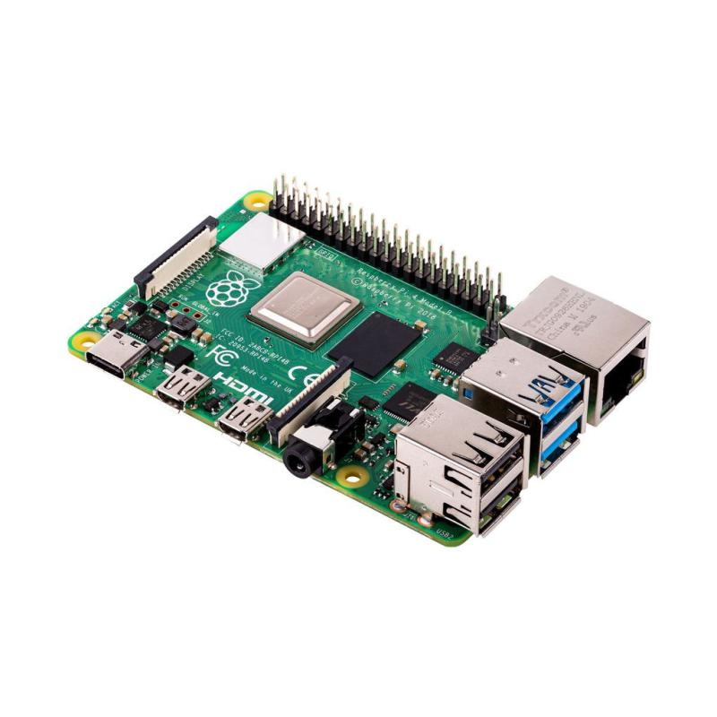

#### 2.2 Microcontroller Selection

The secondary microcontroller is tasked solely with reading GPS data and controlling motors, operating as a slave to the Raspberry Pi 4. This division of responsibilities allows the Raspberry Pi 4 to manage complex computations while the secondary microcontroller handles these specific real-time tasks. By offloading GPS data processing and motor control, the system achieves efficient performance.

The Arduino Uno has been selected for this role due to its simplicity and suitability.

|  |  |
| --- | --- |
| **Feature** | **Arduino Uno Characteristics** |
| **CPU** | ATmega328P, 16 MHz |
| **Memory** | 32 KB Flash, 2 KB SRAM, 1 KB EEPROM |
| **I/O Pins** | 14 digital (6 PWM), 6 analog inputs |
| **Communication** | UART, SPI, I2C |
| **GPS Shield Compatibility** | Compatible with dedicated shields like the Adafruit Ultimate GPS Shield for seamless GPS integration |

The Arduino Uno efficiently handles Boatcleaninge’s GPS data reading (via UART with a Ublox NEO-6M) and motor control (using PWM outputs), acting as a reliable slave to the Raspberry Pi 4. The Uno’s simplicity and affordability make it ideal for real-time tasks in marine environments.

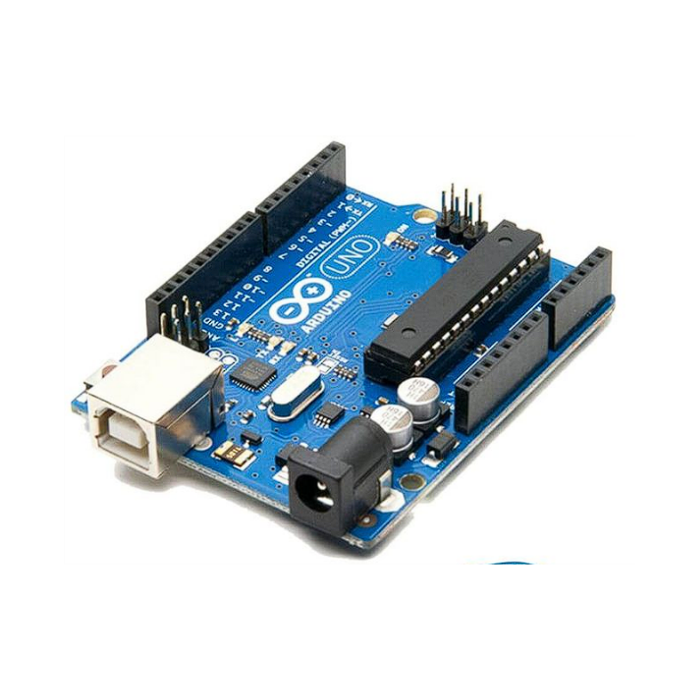

### **Sensors**

Sensors are the perceptive tools that allow *Boat Cleaning* to understand its environment and maintain situational awareness. They collect critical data for navigation, obstacle avoidance, and waste detection in challenging aquatic settings.

#### 3.1 Lidar

To ensure *Boat Cleaning* can effectively navigate and detect obstacles in marine environments, we evaluated three sensor types: RPLIDAR (a LiDAR-based sensor), ultrasonic sensors, and Time-of-Flight (ToF) sensors. The table below compares their key characteristics to determine their suitability for the boat’s autonomous waste collection mission.

|  |  |  |  |
| --- | --- | --- | --- |
| **Feature** | **TOF Sensor** | **Ultrasinc sensor** | **RPlidar 360°** |
| Working Principle | Emits infrared light pulses and measures return time for distance or depth mapping. | Emits high-frequency sound waves and measures echo return time for distance. | Emits laser pulses and measures time-of-flight to create a 360° point cloud for mapping. |
| Range | 0,1m-12m | 0.02 - 4 m | 0.15 - 12 m |
| Field of view | 2° | 30-40° | 360 ° |
| Communication Protocol | UART/I2C | GPIO Timing | UART |
| Suitability for Cleaning Boat | Suitable for precise, short-range waste detection but restricted by its 2° FoV, requiring multiple units for broader coverage. | Useful for close-range obstacle detection but limited by narrow FoV and sensitivity to marine debris. | Ideal for creating detailed 2D maps and avoiding obstacles in open water due to its wide FoV. |

The RPLIDAR remains the top choice for *Boat Cleaning* due to its 360° field of view and high accuracy, enabling comprehensive environmental mapping and navigation in complex marine settings.

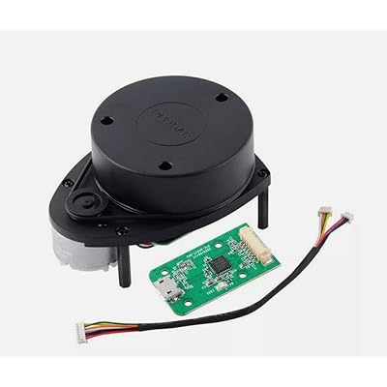

#### 3.2 Camera for Waste Detection

A camera serves as *Boat Cleaning ‘*s key sensor for visual waste detection, capturing images to identify and classify debris in marine environments. Integrated with an AI model, which requires images at a 640x640 resolution, enabling the boat to accurately target waste during its cleanup mission. I have selected a Raspberry Pi Camera, as it integrates seamlessly with the Raspberry Pi 4 , . This resolution requirement guided our research into specific Raspberry Pi Camera types suitable for the project.

The table below compares two Raspberry Pi Camera options—**Camera Module 8MP (60° FoV)**, **Camera Module 8MP (120° FoV)**.

|  |  |  |
| --- | --- | --- |
| **Feature** | **Camera 8MP (60° FoV)** | **Camera 8MP (120° FoV)** |
| **Resolution** | 8MP (3280x2464) | 8MP (3280x2464) |
| **Field of View (FoV)** | 60°, focused for precise waste targeting | 120°, wide for broader environmental scanning |
| **Suitability for Boatcleaninge** | Ideal for precise waste detection with AI | Better for wide-area scanning, less precise |

The Raspberry Pi Camera 8MP with 60° FoV is chosen because its 8-megapixel resolution and focused 60° field of view are optimized for the AI model’s 640x640 input, ensuring precise waste detection. The 120° FoV version is better suited for scanning wider areas but less effective for AI accuracy.

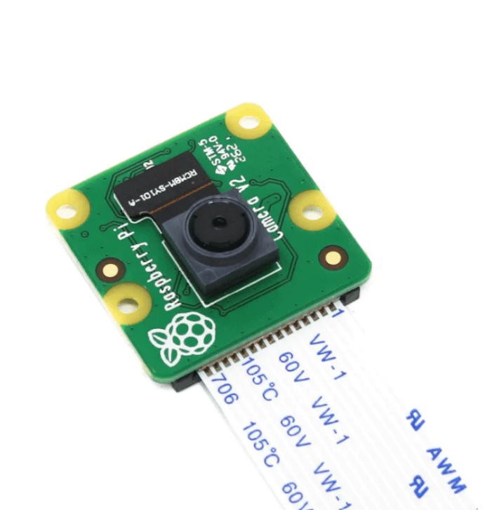

#### 3.3 Gyroscope

The gyroscope is vital for autonomous navigation, measuring angular velocity to track rotational movements and ensure stability. It compensates for wave-induced motions, enabling precise heading control in challenging marine environments.

The table below compares the **6-axis IMU** and **9-axis IMU** to evaluate their suitability for *Boat Cleaning*’s orientation and navigation needs:

|  |  |  |
| --- | --- | --- |
| **Feature** | **6-Axis IMU** | **9-Axis IMU** |
| **Accelerometer (3D)** | Included | Included |
| **Gyroscope (3D)** | Included | Included |
| **Magnetometer (3D)** | Not included | Included |
| **Typical Use Cases** | Motion tracking, drones, basic robotics | Navigation, robotics with compass, marine applications |

The 9-axis IMU was chosen due to its magnetometer, which enables absolute orientation and robust performance in any marine environment. Its protection from magnetic fields ensures reliable navigation, surpassing the limitations of a 6-axis IMU.

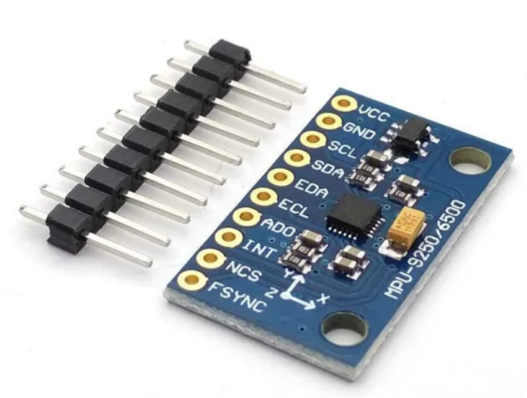

#### 3.4 GPS and SIM Module

**Why we used GPS**  
The GPS is essential for the Ocean Cleanerautonomous navigation, enabling the system to follow predefined map points programmed for waste collection routes. It ensures precise self-localization, allowing robots to determine their position in marine environments accurately.

**Why we used SIM module**  
The integrated SIM (GSM/GPRS) functionality enables *Boatcleaninge* to transmit real-time status updates, such as GPS coordinates and system diagnostics, for remote monitoring.

|  |  |  |
| --- | --- | --- |
| **Feature** | **GPS NEO-6M Micro USB** | **SIM808 GSM/GPS/GPRS Module** |
| **GPS Chipset** | u-blox NEO-6M | MT3336 (SIM808 integrated GPS) |
| **Communication Capabilities** | None (GPS only) | GSM/GPRS (quad-band 850/900/1800/1900 MHz) |
| **Data Transmission** | None | GPRS: max 85.6 kbps downlink/uplink |
| **GPS Sensitivity** | Tracking: -161 dBm, Cold start: -147 dBm | Tracking: -165 dBm, Cold start: -148 dBm |

Tracking sensitivity applies when the GPS module is already locked onto satellite signals and maintaining position data. The SIM808’s -165 dBm is more sensitive than the NEO-6M’s -161 dBm, meaning it can maintain a lock on weaker signals. Cold start sensitivity applies when the GPS module starts without prior satellite data (e.g., after being powered off for a while). The SIM808’s -148 dBm is slightly better than the NEO-6M’s -147 dBm, allowing it to acquire satellites faster in poor conditions. Data Transmission via GPRS on the SIM808 (85.6 kbps) allows robots to send real-time GPS coordinates and diagnostics, a feature absent in the NEO-6M. The SIM808 is better than the NEO-6M for the Ocean Cleaner due to its superior GPS sensitivity and added GPRS communication for remote monitoring.

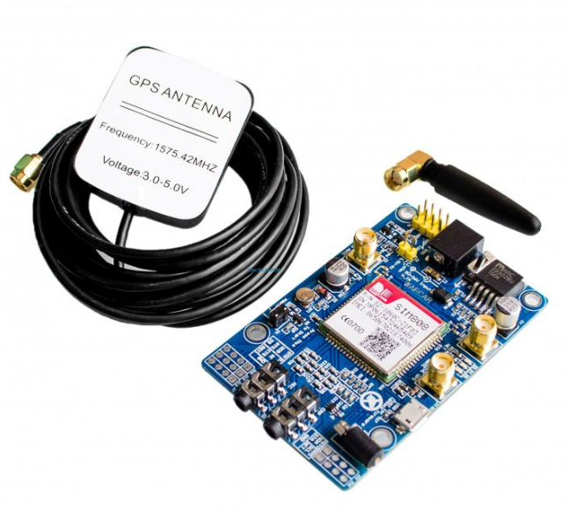

### **Actuators**

Actuators are the components that enable *Ocean Cleaner* to move and execute its waste collection mission in marine environments. They translate control signals from the processing unit into physical actions, ensuring precise navigation and operational efficiency.

To ensure optimal performance of the Ocean Cleaner, the type of motor selected should possess specific characteristics. We recommend using two underwater DC motors that can be seamlessly integrated into the dual-hull design without risking water ingress. These motors should support differential steering, enabling precise navigation and obstacle avoidance in marine environments. Choosing such motors ensures reliable and controlled propulsion, which is essential for the autonomous waste collection mission.

The table below compares the **APISQUEEN U2 MINI 1.3Kg 16V 130W** and **APISQUEEN U01 12V-16V 2Kg 390W** thrusters, evaluating their suitability for *Ocean Cleaner*’s propulsion needs:

|  |  |  |
| --- | --- | --- |
| **Feature** | **APISQUEEN U2 MINI** | **APISQUEEN U01** |
| **Thrust** | 1.3 kg | 2 kg |
| **Voltage** | 12–16 V (3–4S LiPo) | 12–16 V (2–4S LiPo) |
| **Max Power** | 130 W | 390 W |
| **Max Current** | 8 A | 17 A |
| **Weight**  **Arduino Uno Compatibility** | 210 g  Yes, via PWM through motor driver | 178 g  Yes, via PWM through motor driver |

The **APISQUEEN U2 MINI 1.3Kg 16V 130W** thrusters were selected for *Ocean Cleaner* because their lower power consumption (130 W) compared to the U01’s 390 W significantly reduces battery demands, addressing critical power supply constraints for the system.

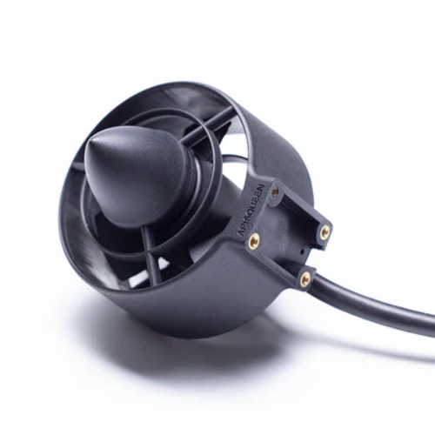

### **Power System**

The power system is a cornerstone of the *Ocean Cleaner* project, as it governs the hours of navigation and directly influences mission duration and efficiency in marine environments. Initially, I decided using a single battery to power all hardware components, including the motors, Raspberry Pi, Arduino, and SIM808 module. This seemed like a straightforward solution to streamline the design. However, the motors’ substantial power demands—each requiring 130 watts and drawing up to 8A of current—revealed a flaw in this approach. A single battery risked overheating under such a heavy load, which could compromise the performance and reliability of the other equipment.

To overcome this challenge, I shifted to a distributed power system. I decided to use separate LiPo batteries for each motor, paired with a power bank to supply the Raspberry Pi, Arduino, and SIM808 module. This solution spreads the power load across multiple sources, reducing the risk of overheating and ensuring that all components operate smoothly and efficiently throughout the mission. By addressing the motors’ high current draw independently, this design enhances the system’s overall stability and supports the *Ocean Cleaner*’s goals in marine cleanup efforts.

#### 5.1 LiPo Battery Selection

For the *Ocean Cleaner* project’s propulsion system, we chose the **Zeee 4S 14.8V 5200mAh 100C LiPo Battery with EC5 Connector**. This battery was selected to meet the high-performance demands of the underwater thrusters while ensuring reliability and efficiency in a marine environment.

* **Voltage (14.8V)**: The 4S configuration delivers 14.8V, which is ideal for powering the motors efficiently, providing the necessary thrust for navigation.
* **Capacity (5200mAh)**: With a 5200mAh capacity, this battery strikes a balance between weight and runtime, allowing *Ocean Cleaner* to operate for extended periods without adding excessive bulk.
* **Discharge Rate (100C)**: The 100C rating enables the battery to supply up to 520A of current (5200mAh × 100C / 1000), far exceeding the 16A needed for two thrusters (8A each). This ensures consistent performance during high-demand situations like wave navigation or rapid maneuvers.

The Zeee 4S LiPo battery’s robust design and high discharge capability make it an excellent match for Ocean Cleaner’s propulsion needs.

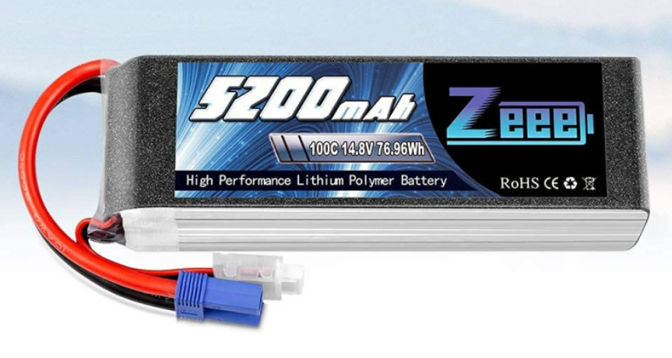

#### 5.2 Power Bank Selection

For the control electronics of Ocean Cleaner, we selected the TECTIN 20000mAh 66W Power Bank with the following specifications: wired connectivity, 66W power output, 20000mAh battery capacity, USB Type-C input, 2 x USB outputs and fast charge capability. This power bank was chosen to provide a stable and versatile power source for the Raspberry Pi and SIM808 module.

* **Capacity (20000mAh)**: The 20000mAh capacity ensures long-lasting power for the Raspberry Pi, Arduino, and SIM808 module, supporting extended missions without frequent recharging.
* **Power Output (66W)**: With a 66W output, it easily handles the combined power needs of the Raspberry Pi (15-20W), Arduino (1-2W), and SIM808 module (2-10W), with ample reserve capacity.
* **Two Ports**: The two USB outputs allow simultaneous powering of the Raspberry Pi and SIM808 module, streamlining the power setup and reducing complexity.
* **Fast Charge**: The fast charge feature reduces downtime by quickly replenishing the power bank between missions.

